

UK
ROUNDERS SET

Contents
Rounders Bat
Ball
4 Posts

For 2 Teams
A team consisting of a maximum of 15 players and a minimum of 6

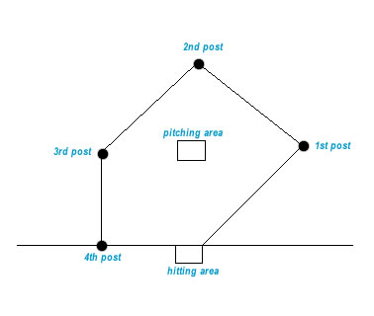
Setting Up
The Rounders pitch is rectangular in shape with areas for throwing the ball to the batter and then posts which must be reached by the batter once they have hit the ball or a no ball is called

Playing the Game

Bowlers must bowl under arm at a height between the knee and head of the batter and without letting the ball bounce, go wide or go straight at the bowler.

1 rounder scored if:
The 4th post is reached before another ball is thrown or
If the 4th post is reached on a no ball.
1/2 rounder scored if:
The 4th post is reached without hitting the ball
The second post is reached after hitting the ball
There is obstruction by a fielder or
There are 2 consecutive no balls.

Ways to be out:
When you are caught by a fielder
You are stumped at a post before reaching it or
If you run inside a post

When at a post you must remain in contact with that post.
When the bowler has the ball in his square you cannot run between posts.
You cannot have more than 1 batter at each post.
You must touch the 4th post on getting home.

Winning the Game
The team that scores the most rounders.

www.traditionalgardengames.co.uk

